CARE AT HOME QUALITY ASSURANCE REVIEW

Care First: |  | Date of Visit:
Persons Name:
Address:
Care Company

Current allocate service – Days/Times

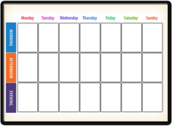

When was the last assessment or review completed on Care First?

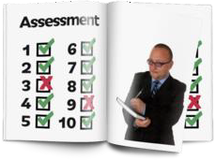

Is an up to date care plan folder in place?



Is the plan easy to follow and does it include important information: e.g. Care Needs, Personal Care, Dietary, Medication, etc:

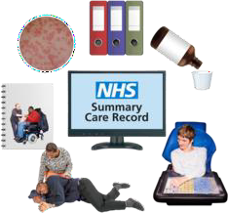

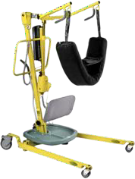
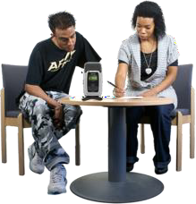
Are there any risk assessments required- if yes- are they in place and up to date- such as Moving and Handling and if any equipment is in situ has it been serviced and certificated/labelled to confirm the same?

Views of the person who receives the service?



Do staff arrive on time?

Do staff wear a uniform, ID badge and wear protective PPE during visits?




Are the care staff friendly and do they treat you with respect?

Does any of your planned visits get missed?

Do you know how to contact the care company?



Have you ever contacted the care company directly to change a visit or make a complaint and if so, what was your experience?

Has the care company ever asked you for your opinion of the service they provide?



View of any family or legal proxy? (Please detail)

Any further feedback or comments you would like to tell us about the quality of the care you receive?


General thoughts about the quality of service you receive?

Follow up Action Points | By Whom | Date

Signature: Person/Representative: Date:

Signed Quality Assurance Officers: Date:

This form should be logged into the SharePoint site for the specific provider.

:

