 

**Sensory Team**

**South Ayrshire**

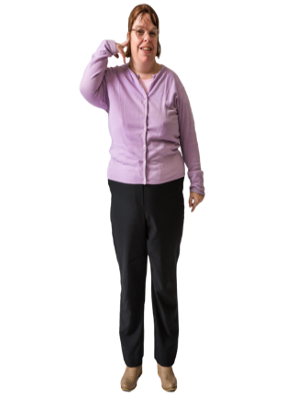We support people who are Deaf or are affected by hearing loss.

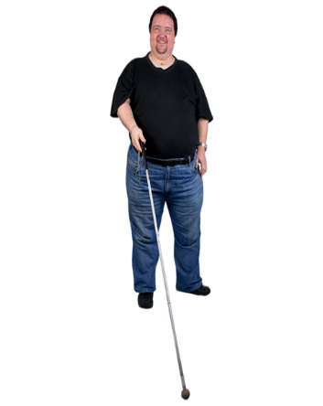We support people who are affected by sight loss.

**We can help with things like –**



Providing emotional support

Information and advice on hearing and vision loss might affect you

Signposting you to other services such as support with welfare benefits

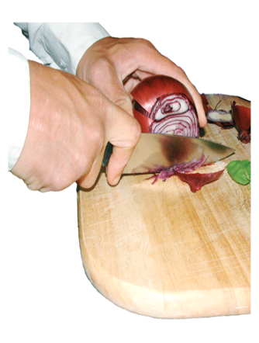

Training on communication and independent living skills

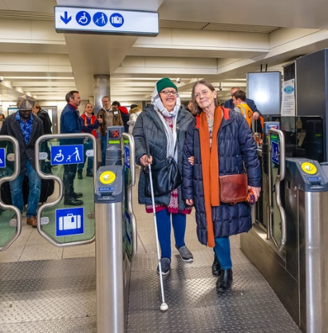

Mobility training to help keep you safe at home and outside your home

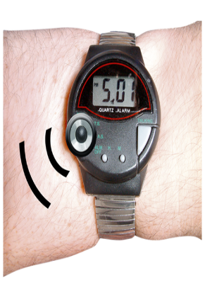

Demonstrating the use of equipment that can help keep you independent

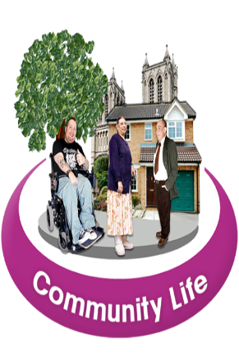

Linking people to their community

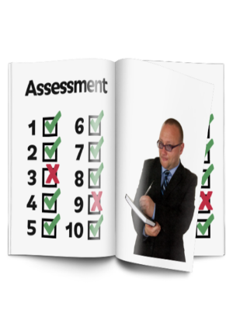

Assessing care and support needs using Self- Directed Support.

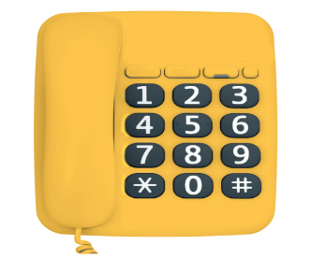Our office is open Monday to Thursday 8.45am to 4.45pm and Friday 8.45am to 4.00pm and you can contact the Sensory Impairment Team by

Telephone: 01292 616637



Email: [Sensory@south-ayrshire.gov.uk](mailto:Sensory@south-ayrshire.gov.uk)

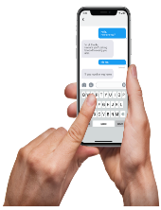

Text: 07977 540721

British Sign Language (BSL) users can contact us via [CS-logo-inLine-email](http://contactscotland-bsl.org/)